2015 PD for new teachers
Gear-up day for new teachers to IDM
Date: Saturday March 21st
Location: The Channel, Hamer Hall (see map below)
Program
9.45-10.00 – Registration
10-11.30 - Introduction and approaches to teaching Units 1-2
11.30-12.00 - Morning Tea included
12.00-1.30 - Introduction and approaches to teaching Units 3-4 – New sample SACs sneak preview
1.30-2.15 - Lunch food court at own expense
2.15-3.30 – Creative Thinking Boot Camp – practical approaches to developing creative thinking skills, directly applicable to compulsory Year 1 Unit
BSBCRT301A Develop and extend critical and creative thinking skills. Also useful for Year 2 Units.

Price: $155 (members $115) for full day
Special price combined membership and full day $200

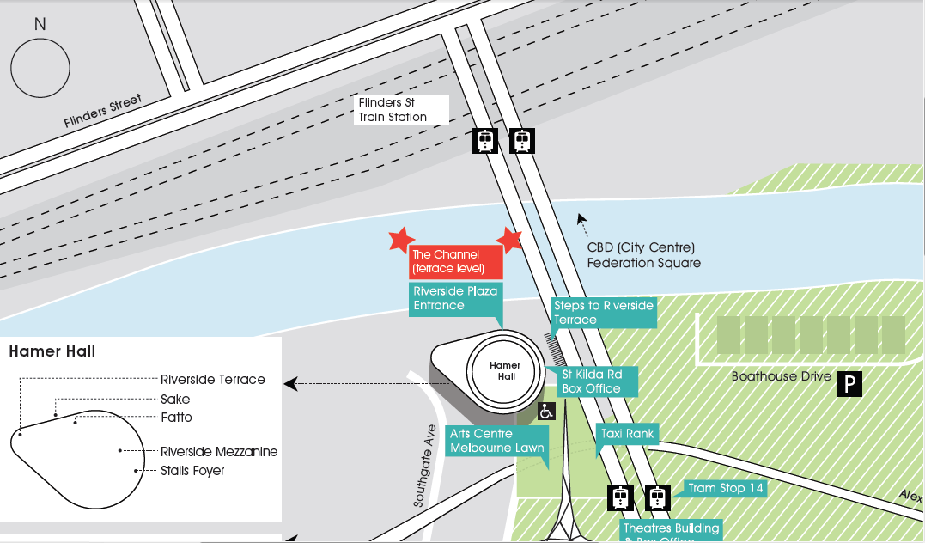

The Channel is in Hamer Hall, on the Terrace Level, enter from the riverside.

